Rory Donley-Lovato

1/27/2021

Web Design

Section 3

Lab 2: Color Theory

1. A Kids Toy Brand Website

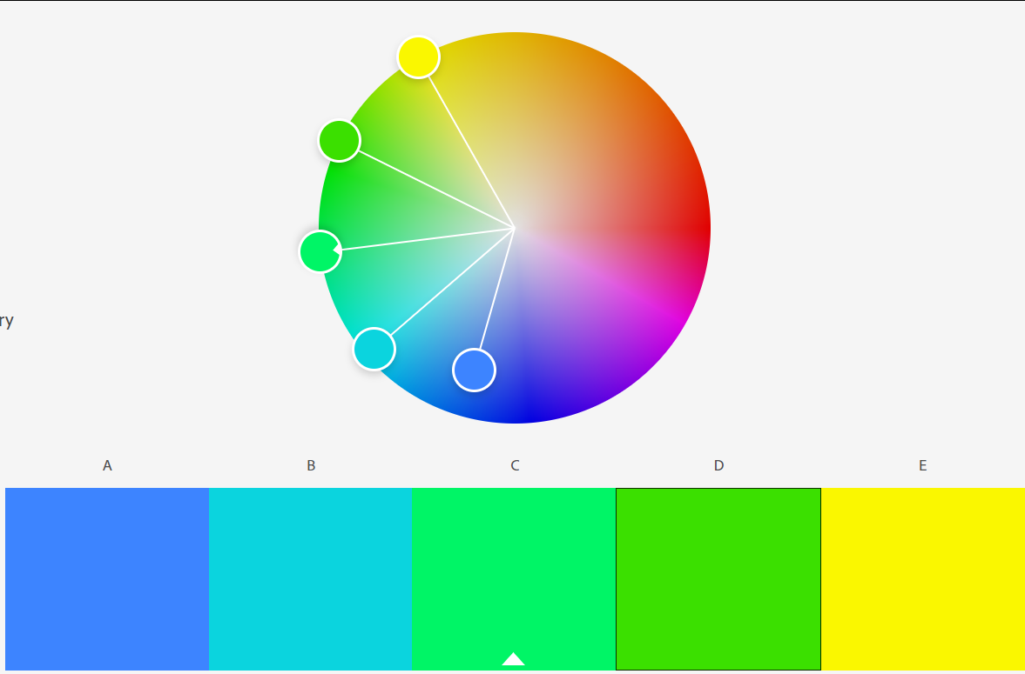

This is the color palette I would choose for a children’s toy website. The three cores colors (yellow, green, and blue) all have positive connotations suitable for child-related products. Yellow shows joy and happiness of a child while only being one of the five colors so that it isn’t overbearing. Green is meant to show growth as a child grows up. Blue shows peace and calm that will be given to the parents if they buy this toy. The shades of blue chosen also match with the baby blue shades that will likely draw more parents to purchase the product. The overall bright color palette is already used by other companies and including it here will place the seed in the parents’ mind that this brand is just as good and will provide as much happiness as a toy from a bigger company.

1. A Heavy Metal Band Website



This is the color palette I would choose for a heavy metal band with my limited understanding of heavy metal. My knowledge of it is that heavy metal is dark and angry, so that is what I am basing my choices off of. The three core colors (black, white, and red) are all based on this dark, angry, aggressive attitude. The connotations with black are power, sorrow, and evil things. This will attract people who feel this way and these emotions match up well with the themes of heavy metal music. White and red are the interesting choices. White is mainly used in stark contrast to the black. It is also in the imagery of skulls, which are very common in the death theme that black portrays. Part of white’s negative meanings are being harsh, cold, and distant. These will often align with heavy metal listeners feelings and attract them to the music even more. Red is my questionable choice of colors. Heavy metal seems to want to stick with the colors white and black, but the meanings behind red place it in the same category. Red is used to show anger, rage, passion, and power, just like black. These themes match the style of heavy metal music and make red an optimal third base color for a website.